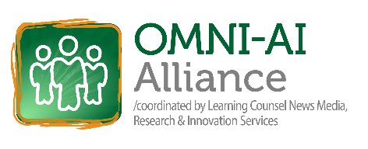

Omni-AI Alliance Gathering 2026 – Chicago, April 15-17th
Continuing Education Unit (CEU) Compliance Statement
This professional learning event is designed and delivered in accordance with the generally accepted Continuing Education Unit (CEU) standard defined by the International Association for Continuing Education and Training (IACET). One CEU is awarded for each 10 contact hours of qualified professional development. The Gathering offers over sixteen (16) hours of educator professional development with a certificate granted for 1 unit equivalent to 10 of those hours.
Envision & Experience | Wednesday April 15th – 4:00 pm – 7:00 pm
Learn | Thursday - April 16th – 8:00am – 5:30 pm
Build | Friday – April 17th – 8:00am – 2:00 pm

Subjects:

- AI schooling models
- Role shifts
- Omni-AI
- Types of AI & Algorithms
- Time-AI & Satellite Schooling
- AI Literacy vs. Fluency
- CRAFT curriculum basics
- AI vs. Human Intelligence, the 5 unique characteristics, revised 9 human intelligence domains
- Top 5 use cases of AI by role
- Types of AI schooling agents
- Tech model architecture
- Missing AI tech standards
- Enterprise-level AI policy setting
- AI schooling space use
- Data literacy
- Managing AI worries
- Overcoming AI schooling obstacles
- Future of Schooling
- AI & schooling trends lines, urgency

This training meets the following CEU compliance criteria:
- Needs Assessment
The content is based on identified educator needs in the areas of administration and instructional innovation, enterprise and learning technologies, operational efficiency, and time-based mastery.
- Learning Outcomes
Measurable learning outcomes are clearly stated and aligned with the session agenda.
- Qualified Instruction
Instruction is delivered by practicing content experts with demonstrated experience in PK–12 systems, learning technologies, and educational transformation.
- Content and Instructional Methods
The program uses a 70+ page Primer of content and accepted adult-learning methodologies, including direct instruction, guided review, collaborative discussion, and application-based problem solving.
- Documented Participation
Participant attendance and completion are verified through sign-in/attendance logs, and digital participation records.
- Assessment of Learning
Participant learning is assessed through session reflection prompts, discussion and final performance-based tasks aligned to the learning outcomes such as turning in a drafted AI policy, or map by role of AI competencies.
- Program Evaluation
Participants complete an evaluation of each sessions content, delivery, and applicability to practice.
- Record Retention
Records of participation, attendance, and evaluations are maintained for a minimum of five years and are available to districts upon request.
Awarding of CEUs / PD Hours
Participants who complete all required components will receive a Certificate of Completion indicating the total eligible contact hours. School districts and state agencies may accept these hours toward professional continuing education credit in accordance with their local policies and regulations.

